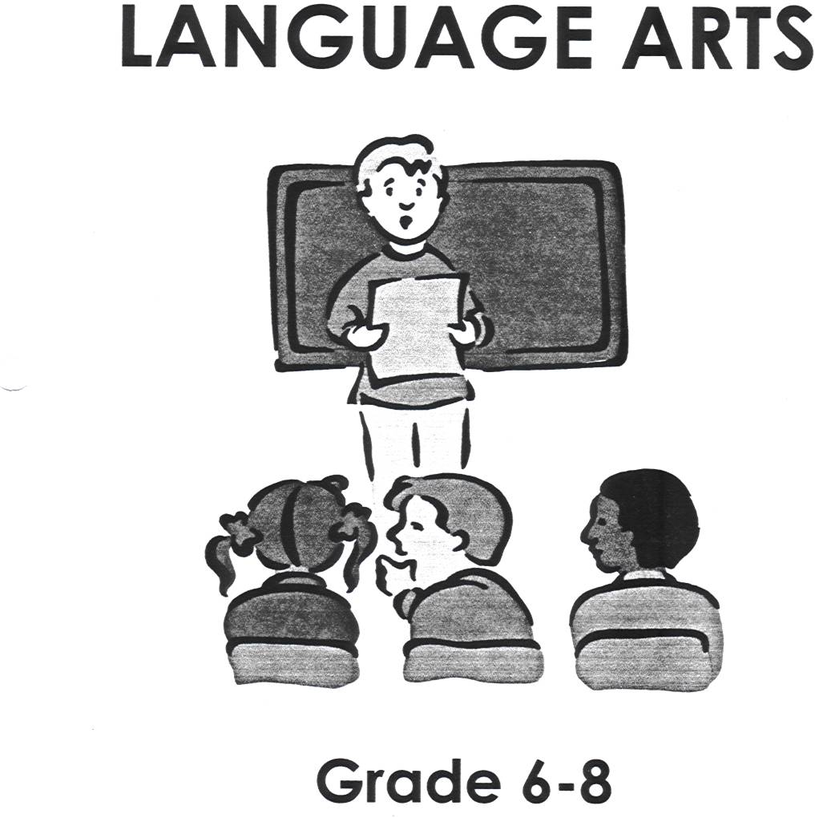

THE NOUN GAME

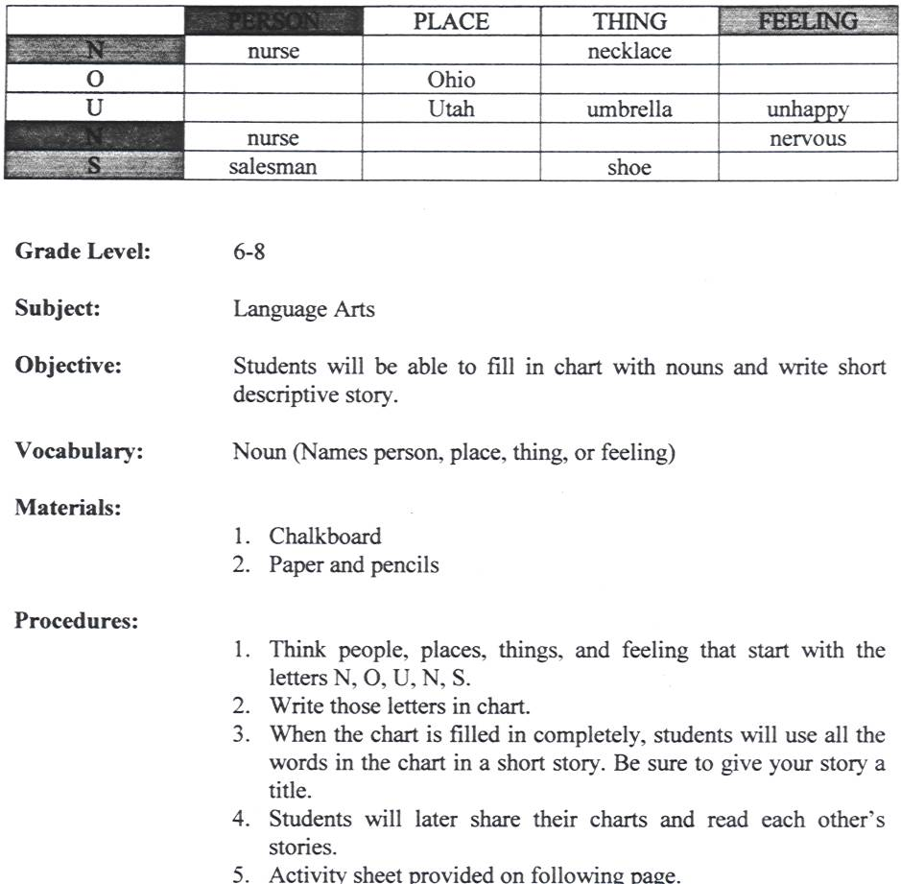

THE NOUN GAME

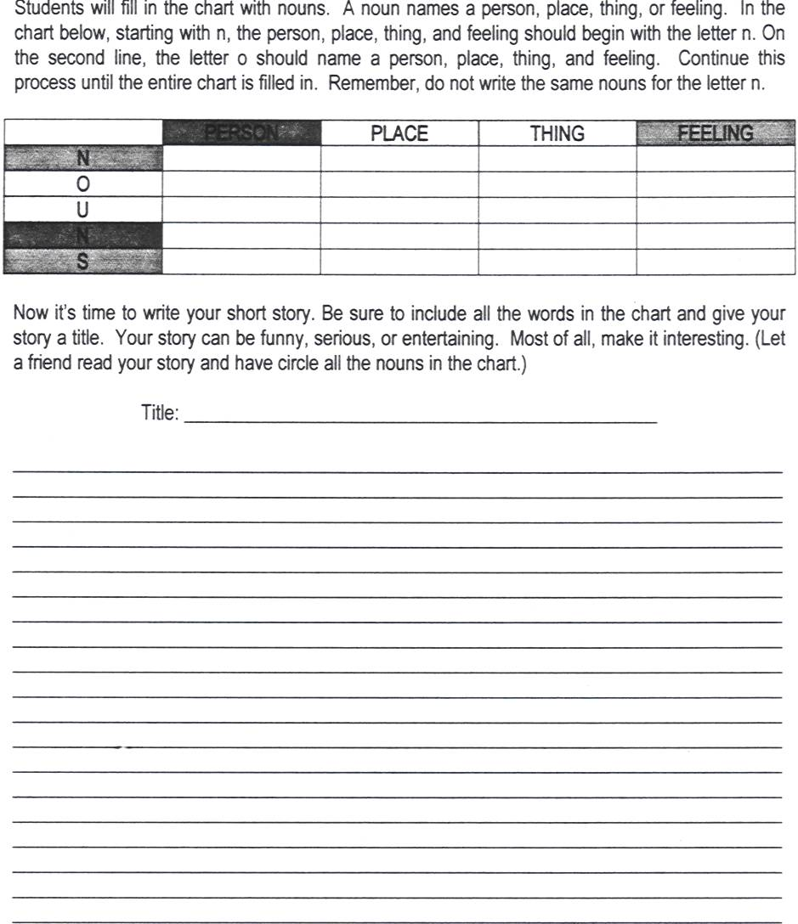

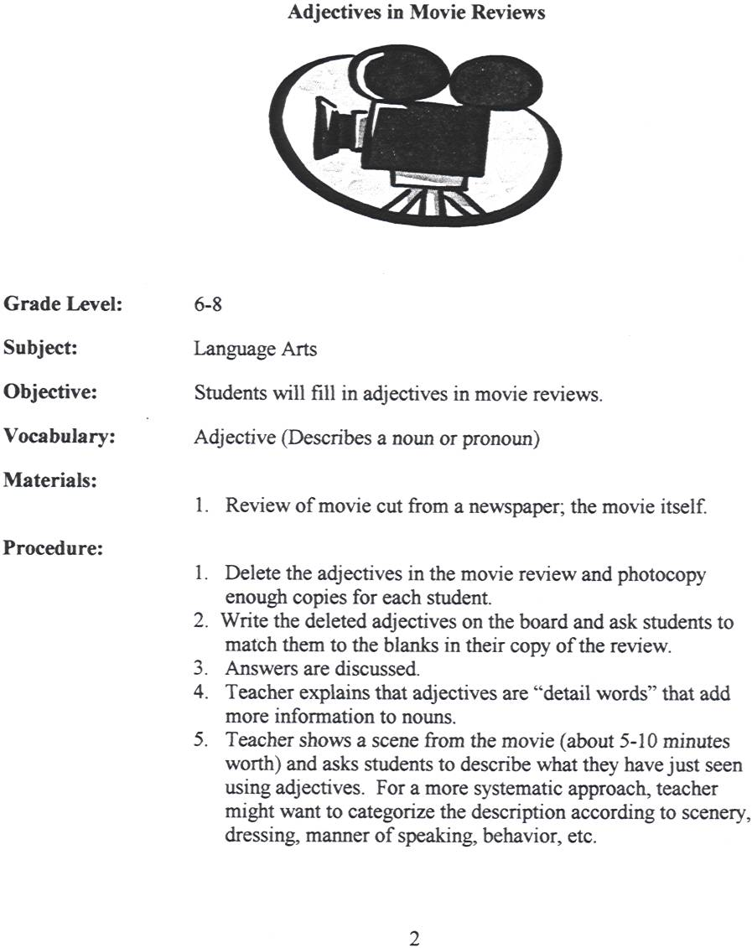

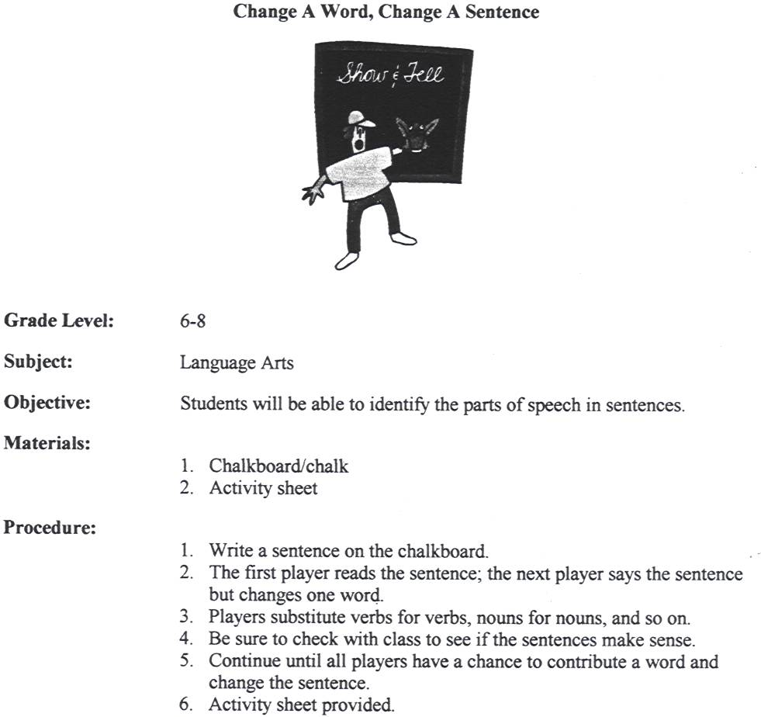
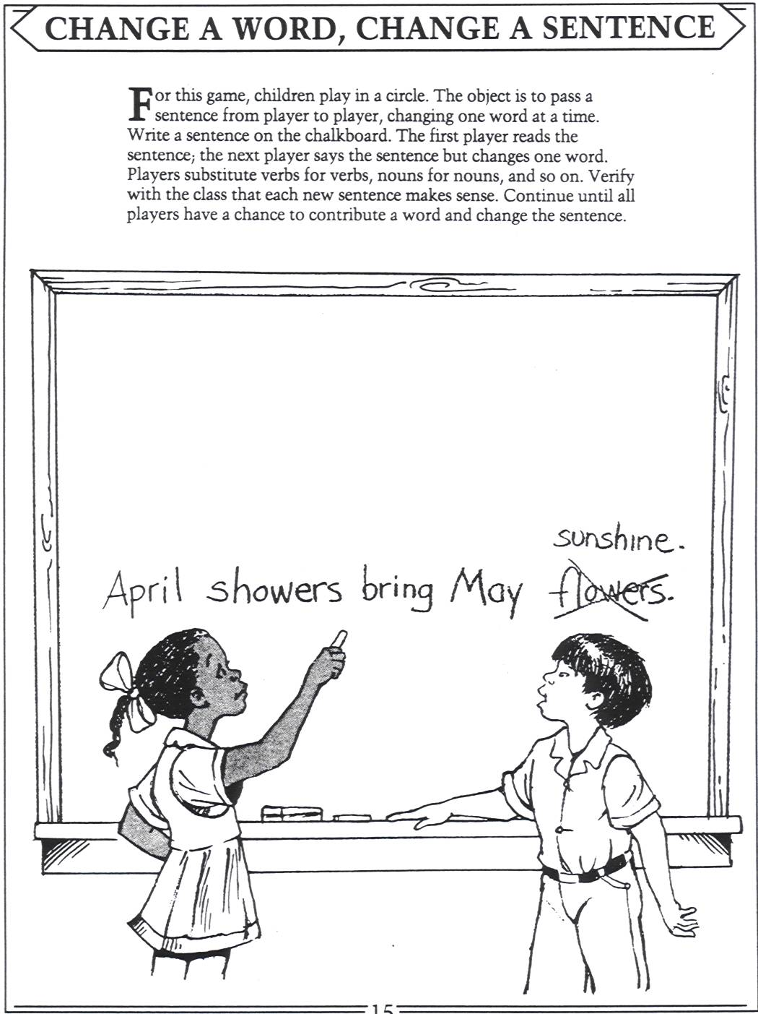
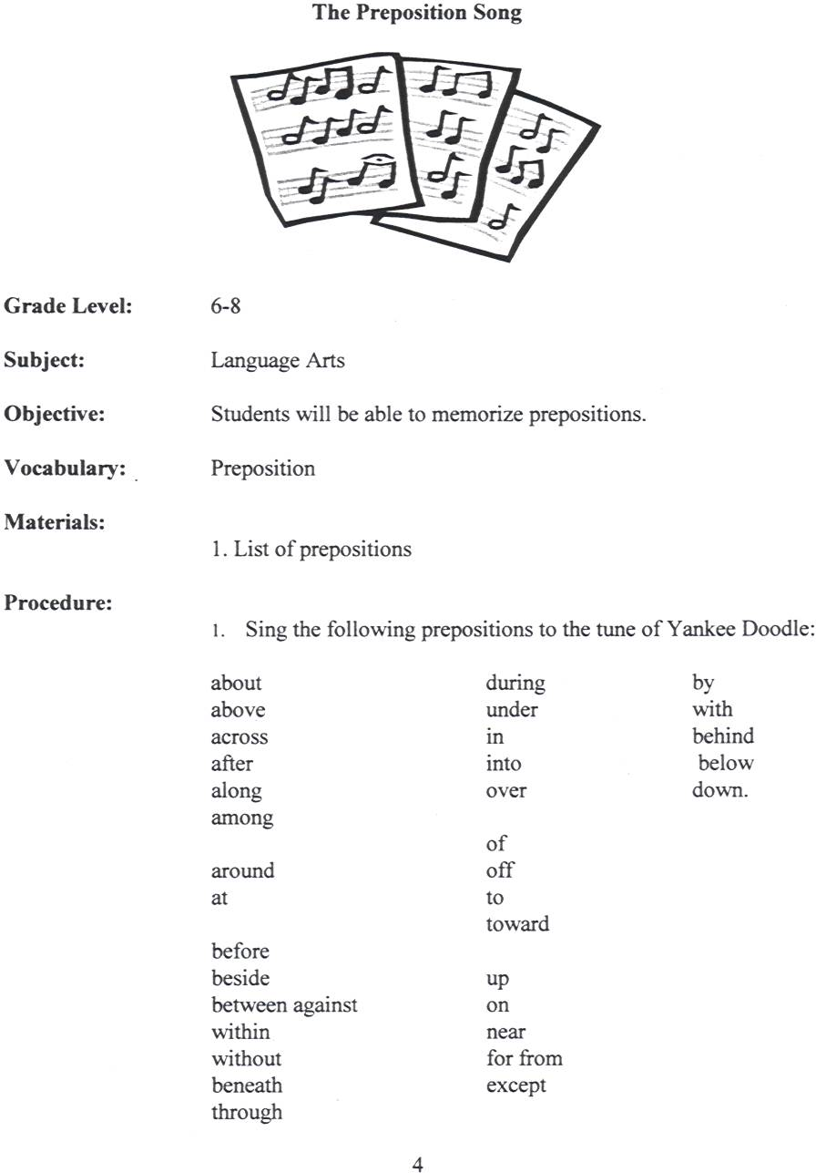

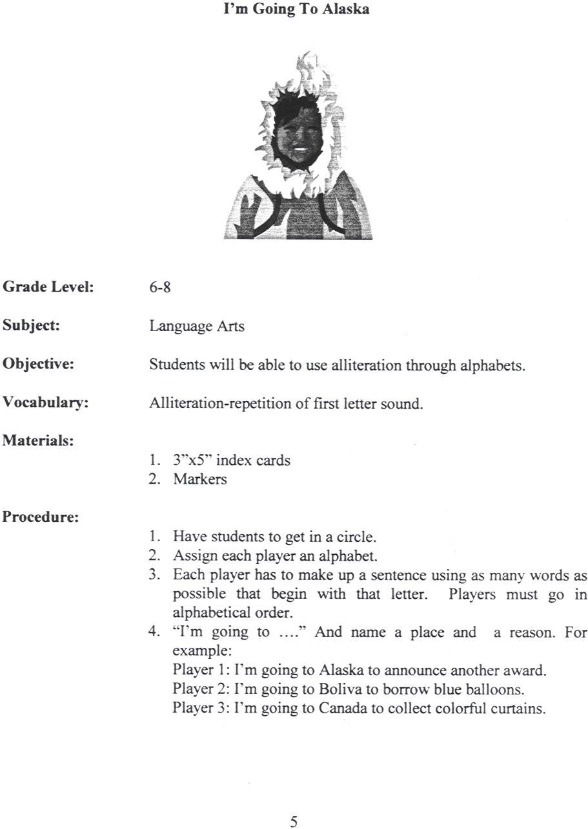

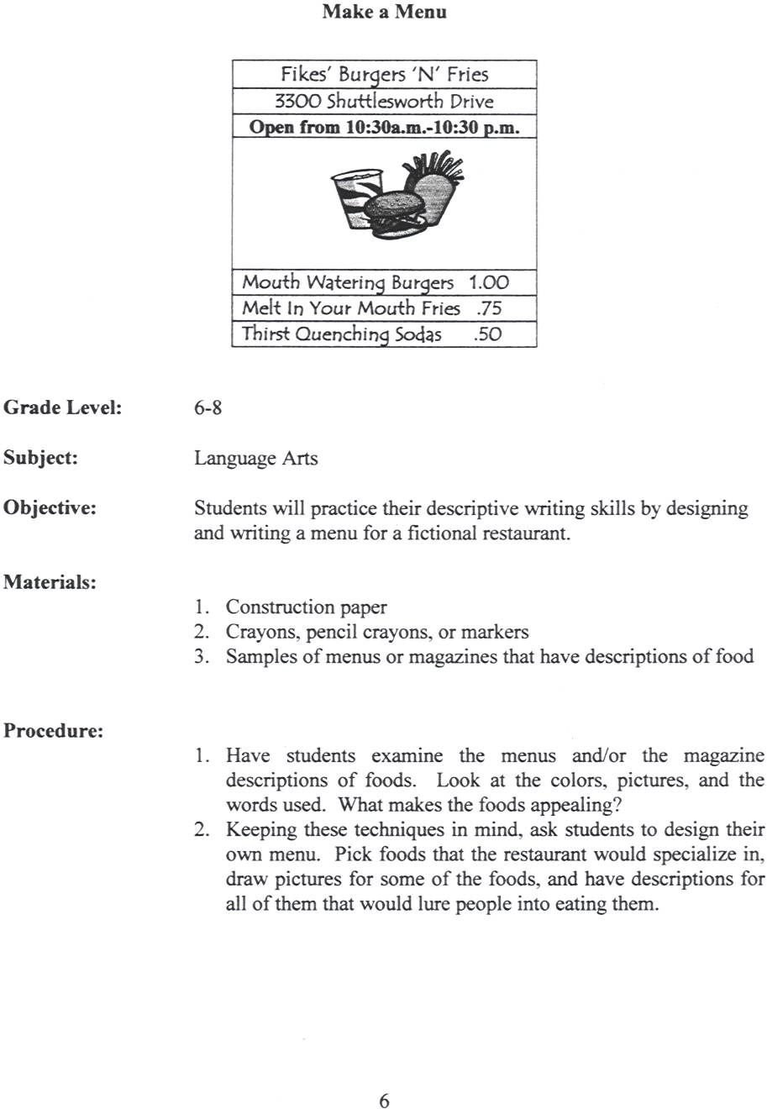
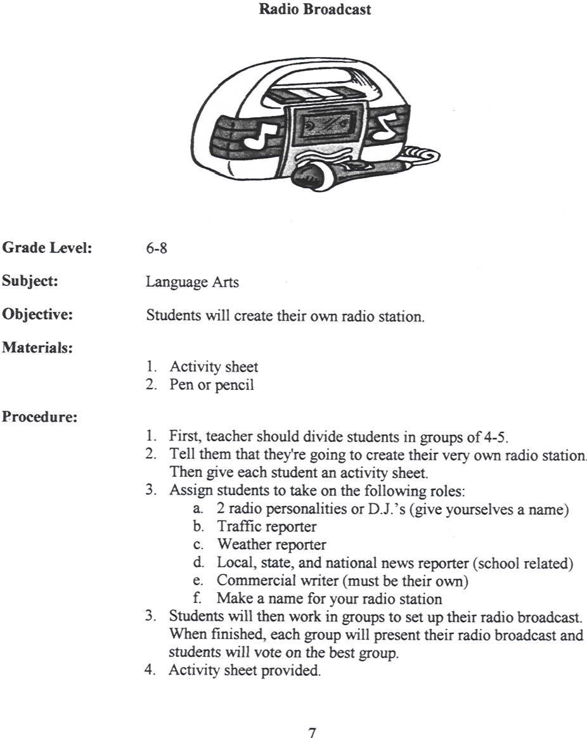

Radio Broadcast


Give your radio station a name and a catch slogan. For example: Hot 86.6 has the hottest hip-hop and old school.

Radio station name and slogan:
_____________________________________________________________________________________________________________________________
_____________________________________________________________________________________________________________________________

Select two students to be the radio personalities. For example: Buckwild and Africa.
Radio personality #1:
_____________________________________________________________________________________________________________________________

Radio personality #2:
_____________________________________________________________________________________________________________________________

Traffic reporter and their report:
_____________________________________________________________________________________________________________________________
_____________________________________________________________________________________________________________________________

Weather reporter and their report:
_____________________________________________________________________________________________________________________________
_____________________________________________________________________________________________________________________________

Local, state, and national news (school related)
_____________________________________________________________________________________________________________________________
_____________________________________________________________________________________________________________________________

Commercials (must have 3 made up on your own).
_____________________________________________________________________________________________________________________________
_____________________________________________________________________________________________________________________________



